Question 2

Diagram

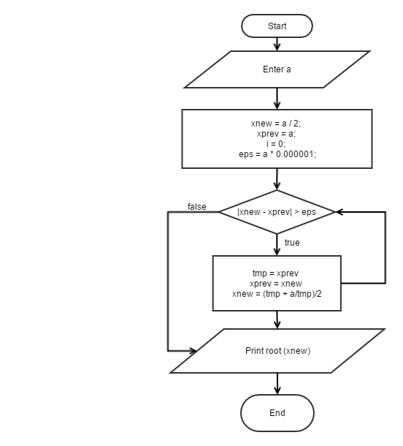

Code:

#include <stdio.h>

#include <stdlib.h>

#include <math.h>

/* run this program using the console pauser or add your own getch, system("pause") or input loop */

int main(int argc, char *argv[]) {

double a, eps, xnew, xprev;

int i = 0;

printf("Enter a number: ");

scanf("%lf", &a);

eps = a * 0.000001;

if (a == 0.0)

{

printf("Root %.5f = %.5f\n", a, a);

}

else

{

xnew = a/2.0;

xprev = a;

while (fabs(xprev - xnew) > eps)

{

i++;

double tmp = xprev;

xprev = xnew;

xnew = (tmp + a / tmp)/2.0;

}

printf("Root %.5f = %.6f, check: %.5f, loop: %d\n", a, xnew, sqrt(a), i);

}

return 0;

}

Result:

|  |  |
| --- | --- |
| **a** | **Root(a)** |
| 2543.00 | 51.06119 |
| 103.56 | 10.17651 |
| 57.23 | 7.56505 |
| 1.50 | 1.22474 |
| 0.0 | 0.0 |
| 0.0035 | 0.05916 |
| 5.70E-10 | 0.000024 |

Question 3

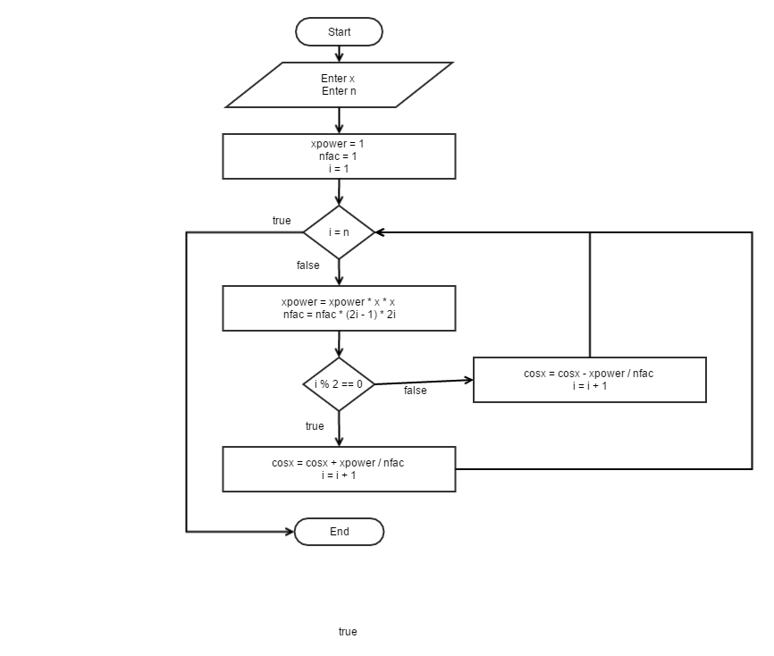

Code

#include <stdio.h>

#include <stdlib.h>

int main(int argc, char *argv[]) {

int n , i, j;

char c;

double x, cosx, xpower, nfac;

while (1)

{

cosx = 1;

xpower = 1;

nfac = 1;

printf("Enter x: ");

scanf("%lf", &x);

printf("Enter n-terms: ");

scanf("%d",&n);

fflush(stdin);

if (n < 1)

{

printf("n must be positive\n");

break;

}

else

{

for (i = 1; i <= n; i++)

{

xpower = xpower * x * x;

nfac = nfac * (2*i-1);

nfac = nfac * 2 * i;

if (i % 2 == 0) cosx += xpower / nfac;

else cosx -= xpower / nfac;

}

printf("cosx = %.5f\n", cosx);

}

while (1)

{

printf("Do you wish to quite (y/n): ");

scanf("%c", &c);

if (c == 'y') return 0;

if (c == 'n') break;

}

}

return 0;

}

Result

|  |  |  |
| --- | --- | --- |
| X | N | Cos(x) |
| 0 | 3 | 1.0 |
| 1.2 | 5 | 0.36236 |
| 3.5 | 7 | -0.93648 |
| 4.6 | 10 | -0.11215 |
| -6.2 | 20 | 0.99654 |
| 12.3 | 30 | 0.96473 |
|  |  |  |